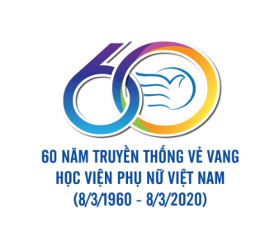 | PRESS RELEASE  On the organization of the international scientific conference  GENDER ROLES IN THE MODERN FAMILY | 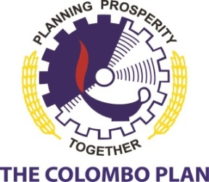
On October 9, 2020, Vietnam Women’s Academy, in collaboration with the Gender Affairs Program (CPGAP) – The Colombo Plan, organizes the international scientific conference on “Gender Roles in the Modern Family”. It is an activity within a series of activities celebrating the 60th of the glorious tradition of Vietnam Women’s Academy’s teachers and students.
The conference is an academic forum for sharing and exchanging scientific research results, discussing issues related to gender roles in implementing modern family functions: enhancing women’s power and gender in care, education,and protection for children; promoting men’s participation and share in housework ,and making policy recommendations to promote gender equality in the family and family sustainability. The conference also contributes to promoting exchanges cooperation among domestic and international scientists as well as creates opportunities for international collaboration in scientific research among regional and international organizations and universities.
The conference will simultaneously be in two modalities: live and online with the participation of prestigious scientists from many domestic universities, research institutes; many authors from Australia, Japan, China, Indonesia, America, Bangladesh, Sri Lanka,; many politicians from the Embassy of Sri Lanka, the Embassy of Australia, the Embassy of Bangladesh, and representatives of major international organizations in Hanoi such as Oxfam, Action Aid, UN Women.
The scientific yearbook of the conference is registered with an ISBN index published with nearly 40 exemplary research papers in Vietnamese and English which were selected from more than 70 articles. The conference will be organized into 4 sessions with 4 main topics: (1) Empowering women in the family, (2) Carrying out economic functions in the modern family, (3) Gender roles in care, education and protection for children, (4) Promoting gender equality in the family.
Time: October 9, 2020
Venue: Room 203 A2 Building, Vietnam Women’s Academy, N.68 Nguyen Chi Thanh, Dong Da, Hanoi.
To join the conference, please confirm your presence before October 7, 2020, through the link: https://bit.ly/3cJKTpv
Best regards!
DIRECTOR OF VIETNAM WOMEN’S ACADEMY

ASS.PROF. Trần Quang Tiến

